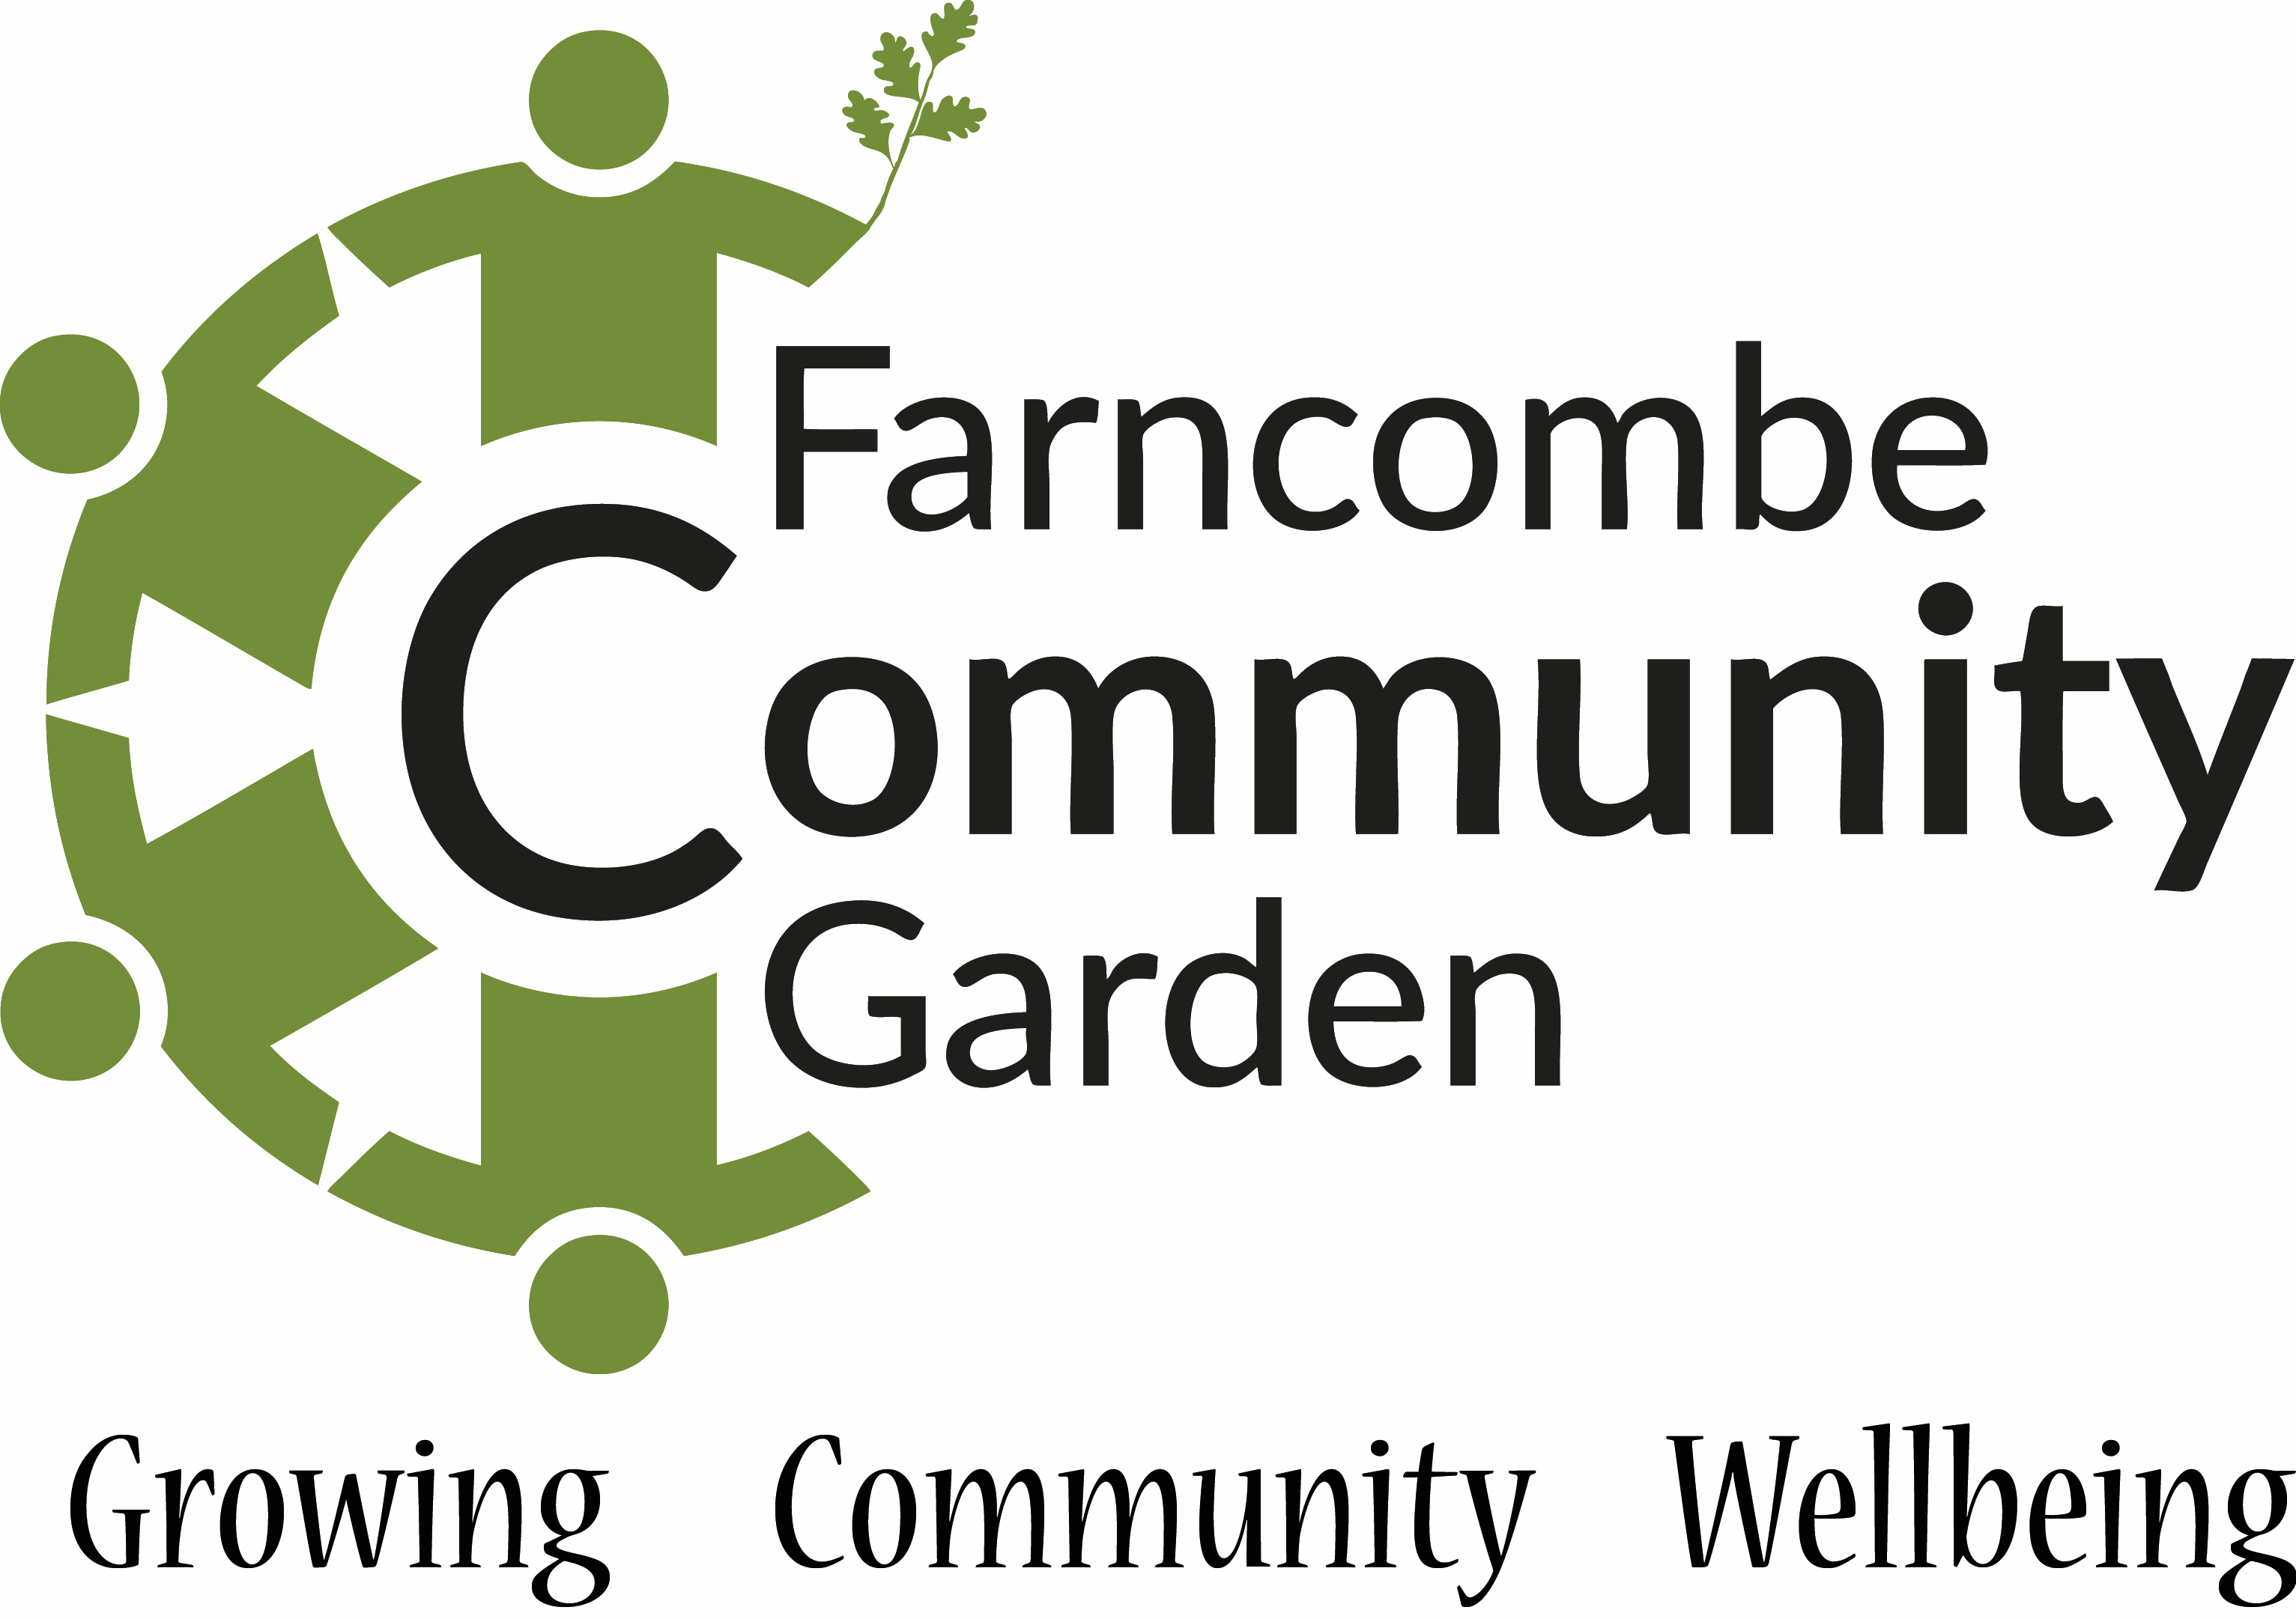

Farncombe Community Garden Trustee role

Role Purpose / Summary
- Provide leadership, inspiration and support to volunteers and fellow trustees.
- Contribute to the setting of the overall strategy and direction of the organisation.
- Create the conditions for volunteers to relax get involved and grow in line with the values of the community garden.
- Maintain and develop the organisation’s resources (human, financial and physical) ensuring financial control.

Key Responsibilities
- Attend and make a positive contribution to quarterly trustee meetings.
- Provide specific skills that help sustain and develop FCG and its volunteers.
- Contribute to the drawing up, and monitoring of, the implementation of internal policies.
- Develop and attend occasional events at the community gardens to promote our activities and volunteering.

Key working relationships
- Fellow Trustees.
- Volunteers & groups using the garden.
- Funders and potential funders.
- The surrounding community.

Liabilities and Legal Requirements
FCG is a Charitable Incorporated Organisation (CIO) whose only voting members are its charity trustees. If the CIO is wound up, the trustees have no liability to contribute to its assets and no personal responsibility for settling its debts and liabilities.
The Organisation has its own bank account with a limited number of signatories.
Trustees may be required to complete Enhanced Disclosure and Barring Service paperwork if they wish to work alone on site with young people or vulnerable adults.

Person Specification
- Our ideal trustee will be constructive, reliable, independently-minded, committed & a good team player.
- Demonstrates diversity & difference, operates with integrity & openness.
- Observes the 7 Nolan Principles of conduct in public life:
Selflessnes
Integrity
Objectivity
Accountability
Openess
Honesty
Leadership

